VA - class 3

Critical reasoning Part 2

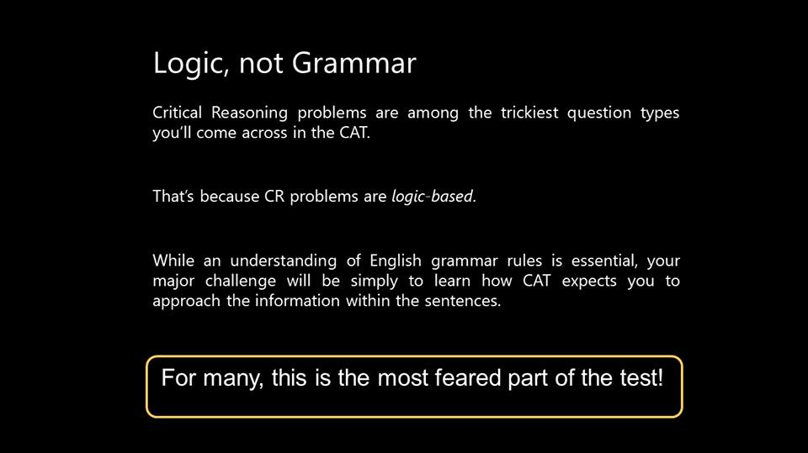

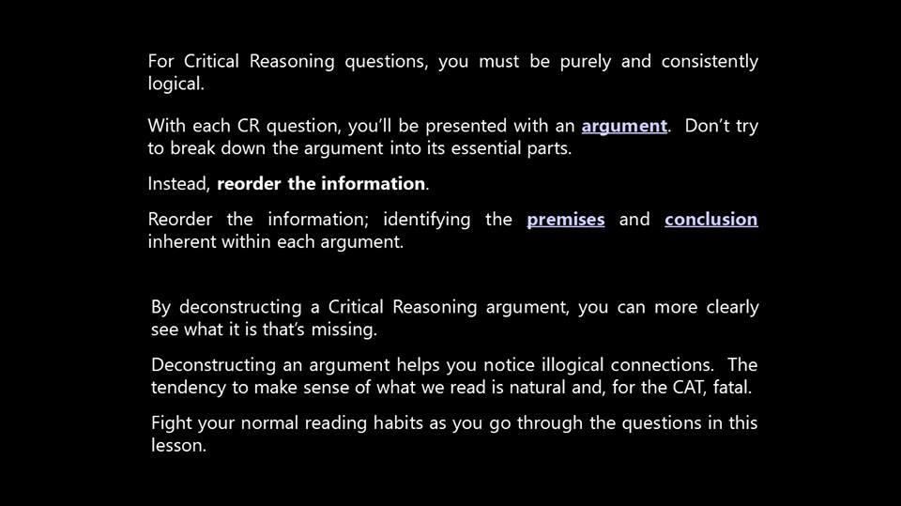

Most trees near busy highways and industrial regions in Japan do not show visible symptoms of damage by air pollution, such as abnormal loss of leaves, slower rates of growth, or higher mortality." So the Weather Watch Division of United Nations decided to raise Japan's carbon credits to 17million as a reward for decreasing the Carbon Footprint.

This is an argument

now reordering or recognising its premise and conclusion

Conclusion – Japan has decreased its carbon footprint.

Premise – Most trees near busy highways and industrial regions in Japan do not show visible symptoms of damage by air pollution, such as abnormal loss of leaves, slower rates of growth, or higher mortality.” So the Weather Watch Division of United Nations decided to raise Japan’s carbon credits to 17million as a reward for decreasing the Carbon Footprint.

now the author will always have an assumption on which his conclusion will depend

the assumption of the author is   
If most trees near busy highways and industrial regions in Japan do not show visible symptoms of damage by air pollution, such as abnormal loss of leaves, slower rates of growth, or higher mortality, this shows decrease in carbon footprint. and trees are the perfect sample tthat represent the whole country

2nd assumption   
if there is NO VISIBLE SYMPTOM, there is no ACTUAL damage

identify the premise, conclusion and assumption of the following argument

( Do not comment the answers, I will post all these after 2 minutes. you can simply cross check and then ask doubts )

ARGUMENT  
A psychometric test is an essential part of a successful placement program because, with it, job applicants who  
have personalities that are unsuited to the requirements of the job will be eliminated from consideration.

my answers:

c : psychometric test is essential part of successful placement.

p : job applicants who  
have personalities that are unsuited to the requirements of the job will be eliminated from consideration

a: psychometric test are accurate.

Conclusion – A psychometric test is an essential part of a successful placement program

Premise – With a psychometric test, job applicants who have personalities that are unsuited to the requirements of the job will be eliminated from consideration.

Assumptions – A psychometric will be able to identify job applicants who have personalities that are unsuited to the requirements of the job

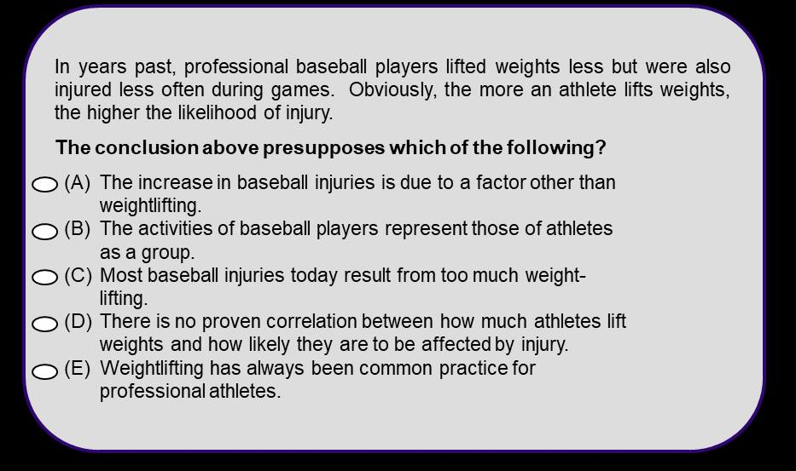

OA : b

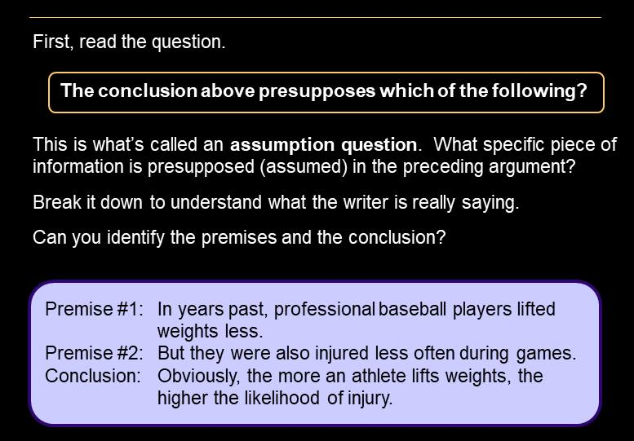

in this particular question, the author gives us the conclusion of athletes but the data given is that of professional baseball players.

Remember : there will always be a GAP between the conclusion and the premise.

the GAP in this specific question is that the author has NOT shown ANY LINK between athlete and baseball player. this is called analogy flaw

an Assumption is like a bridge between premise and conclusion.

thus the assumption for this argument is that the athletes and baseball players are one and the same or they are related or they are linked through their activities

so any option that matches our given answer will be the right option

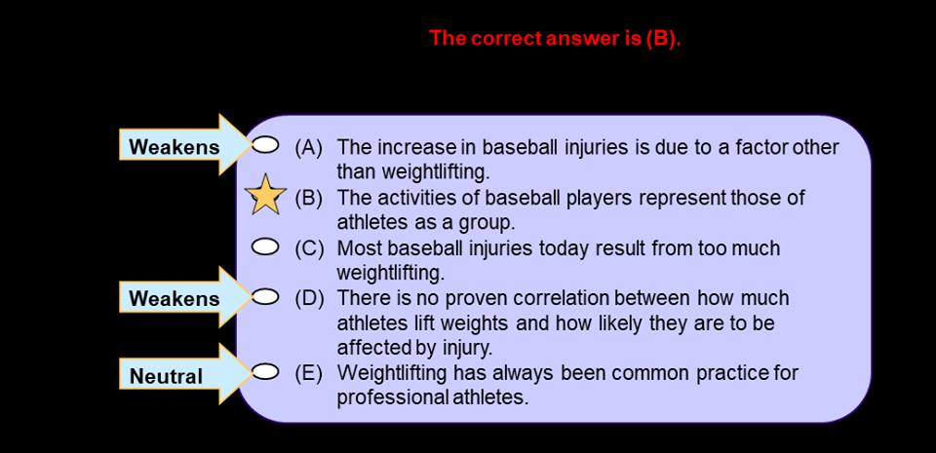

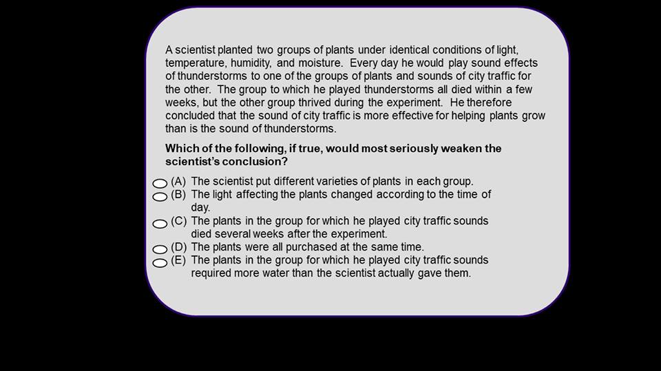

OA : A

[#CR3ans](https://www.facebook.com/hashtag/cr3ans?source=feed_text) : A

the scientist concluded that the sound of city traffic is more effective for helping plants grow than is the sound of thunderstorms.

premise : A scientist planted two groups of plants under identical conditions of light, temperature, humidity, and moisture. Every day he would play sound effects of thunderstorms to one of the groups of plants and sounds of city traffic for the other. The group to which he played thunderstorms all died within a few weeks, but the other group thrived during the experiment

GAP : has he shown that the plants were same ..no. he shows that the other condition are identical ..   
the assumption therefore is that the plants are also identical ..

thus A ..

C is the second best answer. the question asks which option BEST WEAKENS ..   
in such cases two options will be close .. we need to see which is more suitable

A says .. plant were different so the experiment was totally flawed

2 mins   
Research shows that adolescents who play video games on a regular basis are three times as likely to develop carpal tunnel syndrome as are adolescents who do not play video games. Federal legislation that prohibits the sale of video games to minors would help curb this painful wrist condition among adolescents.

The doctor’s conclusion depends on which of the following assumptions?

A. The majority of federal legislators would vote for a bill that prohibits the sale of video games to minors.  
B. Not all adolescents who play video games on a regular basis suffer from carpal tunnel syndrome.  
C. Playing video games is the only way an adolescent can develop carpal tunnel syndrome.  
D. Most parents would refuse to purchase video games for their adolescent children.  
E. The regular playing of video games by adolescents does not produce such beneficial effects as better handeye coordination and improved reaction time.

D  
doctor's conclusion : Federal legislation that prohibits the sale of video games to minors would help curb this painful wrist condition among adolescents.

his assumption : if there is a ban to sell to minors, minors won't be able to get the video games from other sources. he believes there is ONLY ONE SOURCE of getting the video games BUYING THEM DIRECTLY from the store ...   
what if there are other ways

so ?

A. The majority of federal legislators would vote for a bill that prohibits the sale of video games to minors.

[ WRONG.. because the doctor's conclusion is bases on EFFECTIVENESS Of the ban .. A could be there had D not been present]

B. Not all adolescents who play video games on a regular basis suffer from carpal tunnel syndrome.  
[ this weakens the Doctor's conclusion]

C. Playing video games is the only way an adolescent can develop carpal tunnel syndrome.  
[ No.. CLOSE one .. but we NEED TO ATTACK THE conclusion directly. .. the assumption should RELATE to the BAN.. and then to something else ]

D. Most parents would refuse to purchase video games for their adolescent children.  
[ YES .. this is his assumption as he believes that if adolescents cannot buy themselves.. others won't also buy for them]

E. The regular playing of video games by adolescents does not produce such beneficial effects as better handeye coordination and improved reaction tim  
[ HUH ??? ]

OK FOLKS. that is it for today. I will upload a CR file by tomorrow which you need to solve by Tuesday. We will have a dicsussion on that  
Till then thanks for the support and the session.   
good night. see you soon